Sitemap URL-

https://secure-house.co.uk/sitemap_index.xml
https://secure-house.co.uk/post-sitemap.xml
https://secure-house.co.uk/post-sitemap2.xml

https://secure-house.co.uk/avada_portfolio-sitemap.xml
https://secure-house.co.uk/category-sitemap.xml
https://secure-house.co.uk/post_tag-sitemap.xml
https://secure-house.co.uk/fusion_tb_category-sitemap.xml

https://secure-house.co.uk/portfolio_category-sitemap.xml

https://secure-house.co.uk/element_category-sitemap.xml
https://secure-house.co.uk/slide-page-sitemap.xml
https://secure-house.co.uk/author-sitemap.xml

Robots.txt

https://secure-house.co.uk/robots.txt

User-agent: *
Disallow: /wp-admin/
Allow: /wp-admin/admin-ajax.php

Host: secure-house.co.uk
Sitemap: https://secure-house.co.uk/sitemap_index.xml

Thank You Page
https://secure-house.co.uk/thank-you/

GSC,GA4 & GTM Code

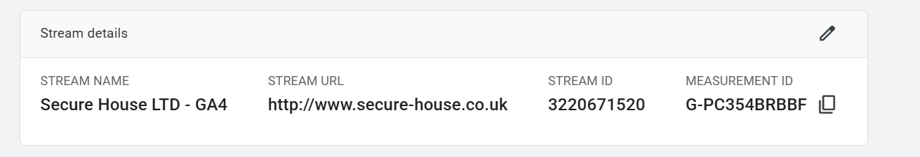

GA4

<!-- Google tag (gtag.js) -->
<script async src="https://www.googletagmanager.com/gtag/js?id=G-PC354BRBBF"></script>
<script>
window.dataLayer = window.dataLayer || [];
function gtag(){dataLayer.push(arguments);}
gtag('js', new Date());

gtag('config', 'G-PC354BRBBF');
</script>

GSC
1. Copy the meta tag below, and paste it into your site's home page. It should go in the <head> section, before the first <body> section.

<meta name="google-site-verification" content="edxXEeyWtd6YDmc7jkuwID3cQnresUn5GIcq6hDwr_8" />

CTAs

High Security Doors

Page URL: https://secure-house.co.uk/doors/high-security-doors/

CTA Heading: Protect What Matters Most

CTA Text: Get a bespoke high-security door designed for your property and security requirements.

CTA Button: Get a Free Consultation

Panic Room Doors

Page URL: https://secure-house.co.uk/doors/panic-room-doors/

CTA Heading: Create Your Ultimate Safe Space

CTA Text: Speak with our experts about a bespoke panic room door built for discreet, dependable protection.

CTA Button: Discuss Your Safe Room

Industrial Style Doors

Page URL: https://secure-house.co.uk/doors/industrial-style-doors/

CTA Heading: Bring Industrial Style to Your Space

CTA Text: Explore bespoke steel and glass door solutions that combine a striking industrial look with lasting performance.

CTA Button: Explore Bespoke Designs

Bullet Proof Doors

Page URL: https://secure-house.co.uk/doors/bullet-proof-doors/

CTA Heading: Choose Protection Built Around Your Needs

CTA Text: Talk to our specialists about a bespoke ballistic door solution for your home, business, or high-security property.

CTA Button: Get Expert Advice

Communal Entrance Doors

Page URL: https://secure-house.co.uk/doors/communal-entrance-doors/

CTA Heading: Secure Every Entrance

CTA Text: Get a durable, made-to-measure communal entrance door designed for your building and access requirements.

CTA Button: Request a Quote

Security Shutters

Page URL: https://secure-house.co.uk/grilles-shutters/security-shutters/

CTA Heading: Secure Your Property After Hours

CTA Text: Find the right security shutter solution for your property with expert guidance and bespoke options.

CTA Button: Get a Security Shutter Quote

Sectional Garage Doors

Page URL: https://secure-house.co.uk/garage-doors/sectional-garage-doors/

CTA Heading: Upgrade Your Garage Entrance

CTA Text: Choose a sectional garage door tailored to your space, style, and security requirements.

CTA Button: Explore Your Options

Garage Doors

Page URL: https://secure-house.co.uk/garage-doors/

CTA Heading: Find the Right Garage Door for Your Property

CTA Text: Speak with our team to explore secure, durable, and made-to-measure garage door solutions.

CTA Button: Get a Free Quote

Side Hinged Garage Doors

Page URL: https://secure-house.co.uk/garage-doors/side-hinged-garage-doors/

CTA Heading: Classic Access, Modern Performance

CTA Text: Discover a side-hinged garage door designed around your space, style, and everyday access needs.

CTA Button: Design Your Garage Door

Fire Resistant Doors

Page URL: https://secure-house.co.uk/doors/fire-resistant-doors/

CTA Heading: Put Fire Safety at the Heart of Your Project

CTA Text: Talk to our specialists about a fire-resistant door solution suited to your property's requirements.

CTA Button: Speak to a Specialist

Bespoke Doors

Page URL: https://secure-house.co.uk/doors/bespoke-doors/

CTA Heading: Your Door, Designed Your Way

CTA Text: Create a made-to-measure door that matches your property's style, dimensions, and functional requirements.

CTA Button: Start Your Bespoke Design

Victorian Front Doors

Page URL: https://secure-house.co.uk/doors/victorian-front-doors/

CTA Heading: Give Your Entrance Timeless Character

CTA Text: Design a bespoke Victorian front door that combines classic style with modern security.

CTA Button: Design Your Victorian Door

